“Amigo Brothers” Comic Strip Plot Diagram
DIRECTIONS:
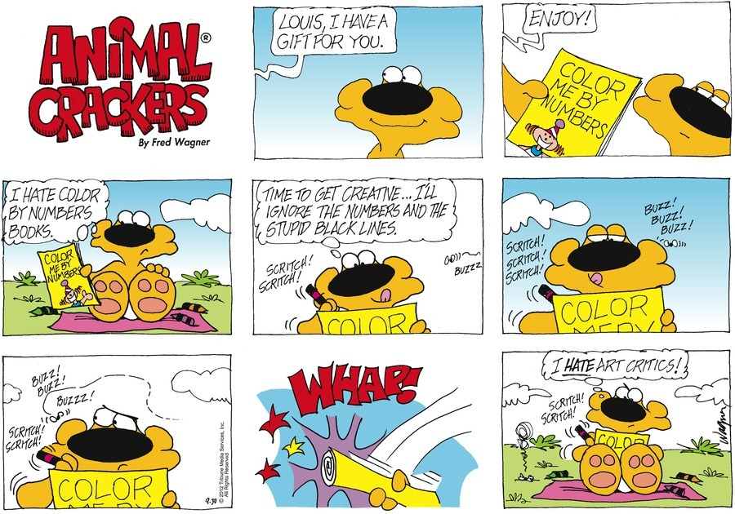
You have learned that PLOT is the sequence of events that makes up a story. You have also just finished reading Piri Thomas’ short story, “The Amigo Brothers.” Now, you will demonstrate (show) your understanding of PLOT by creating a comic strip that represents the Plot Diagram of the story. Comic strips use DIALOGUE and pictures to tell a story. Your job is to “tell” me the PLOT of “Amigo Brothers” in comic strip-form. Here is an example of a comic strip…
Your Comic Strip MUST INCLUDE:
- A Rough Draft (use back) showing the story events you will use in your Final Comic Strip _____/10 PTS
- 1 frame showing the EXPOSITION (SETTING and MAIN CHARACTERS) of the story _____/10 PTS
- 3 frames showing 3 different RISING ACTION events (events that occur before the climax) _____/30 PTS
- 1 frame showing the CLIMAX (the most intense part/turning point) of the story _____/10 PTS
- 1 frame showing a FALLING ACTION event (an event after the climax) _____/10 PT
- 1 frame showing the RESOLUTION (end/solution to the conflict) of the story _____/10 PTS
- AT LEAST 5 examples of DIALOGUE (shown through “speech bubbles”) in your Comic Strip _____/10 PTS
- CHARACTERIZATION that clearly shows the difference between the story’s characters _____/10 PTS
TOTAL: _____/100 POINTS
EXPOSITION
RISING ACTION #3
CLIMAX
FALLING ACTION #1
RISING ACTION #2
RISING ACTION #1
RESOLUTION

