Breaking Down the Story Steps
Directions: For each of the nine points on the Storytelling Arc below, summarize the plot point and give one line of text from that part of the story. If you don’t have enough room to write on this sheet, feel free to number your answers and write Climax
them on the back.
Exposition
Conflict Introduced
Rising Action
Resolution
Falling Action
1
2
3
4
5
6
8
7
9

Breaking Down the Story Steps KEY
Rising Action
Falling Action
Directions: For each of the nine points on the Storytelling Arc below, summarize the plot point and give one line of text from that part of the story. If you don’t have
Storytelling Arc

#6
Summary: Montresor attacks, locks

enough room to write on this sheet, feel free to number your answers and write Climax Fortunato in chains, and seals him up inside

them on the back.
For this sample, I used Edgar Allan Poe’s classic tale of terror, “The Cask of Amontillado.”

#1
Summary: At the beginning of the story, Montresor is a bitter man who wants revenge against an associate of his named Fortunato. Text: “At length I would be avenged; this was a point definitely settled–but the very definitiveness with which it was resolved precluded the idea of risk.”

1 2 Exposition
#4 Summary:
Montresor pretends to be concerned for Fortunato’s health and feigns that they should turn back and leave the catacombs, knowing Fortunato will insist they move forward. Text: “We will go back. You will be ill, and I cannot be responsible.”
3
a wall.
6 Text: “A moment more and I had him fettered
#5 to the granite.”
Summary: Montresor
offers Fortunato another #7
drink because he secretly Summary: Montresor wants to keep his victim
intoxicated. stabs Fortunato with his
Text: “A draught of this sword and drops a flame Medoc will defend us in the space, just to make
from the damps.” 5 7 sure that Fortunato will die
there.
Text: “I placed my hand upon the solid fabric of catacombs, and felt satisfied.”
4 #8Summary: Montresor
finishes the wall, confident 8 9 that the job is done. Resolution
Text: “I forced the last stone into its position; I plastered it up.”

#3
#9
Summary: Montresor shakes hands
Summary: Fifty years have with Fortunato and tells about the rare passed and now Montresor is Amontillado he has purchased. telling the tale. Apparently, he
Text: “But I have received a pipe of what got away with the crime. passes for Amontillado, and I have my
Text: “For the half of a century, doubts...You were not to be found, and I no mortal has disturbed [the was fearful of losing a bargain.” wall of bones].”

#2
Summary: Montresor crosses paths with Fortunato and the opportunity arises to spring his trap.

Conflict Introduced Text: “It was about dusk, one evening during the supreme madness of the carnival season, that I encountered by friend.” Oh, the irony of “friend” here.
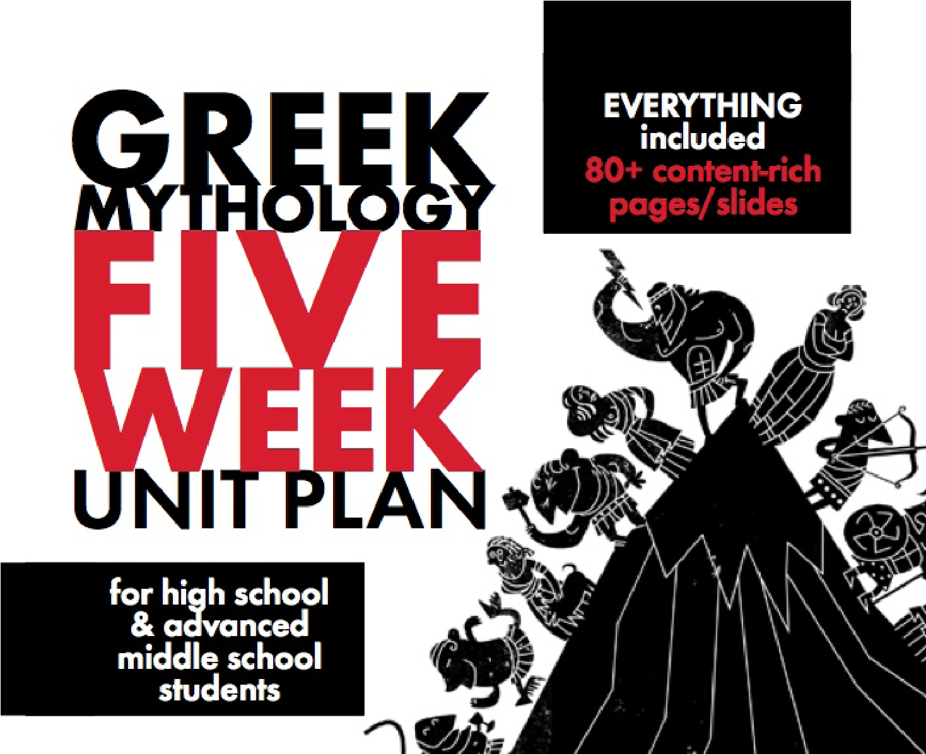
For more
FREE
and budget-priced
teaching materials, visit my store at:
http://www.teacherspayteachers.com/Store/
Laura-Randazzo

