Name__________________________
Plot Diagram for “Eleven”
Plot is the literary element that describes the structure of a story.
A plot diagram shows how the main events in a story are organized into a plot.
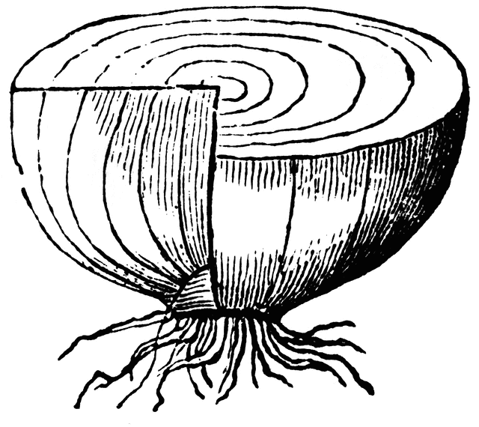
I. Exposition

Characters:

Setting:

Conflict:

II. Rising Actions
1._______________________________________________________________________________________________________2._______________________________________________________________________________________________________3._______________________________________________________________________________________________________
III. Climax
__________________________________________________________________________________________________________________________
IV. Falling Action
_________________________________________________________________________________________________________

V. Resolution
______________________________________________________________________
VI. Theme
______________________________________________________________________________________________________

