CERTIFIED RENT ROLL

As of date:

Property Name

Property Address

List unoccupied units as "VACANT" in the tenant column. Please fill out separate rent roll for all properties
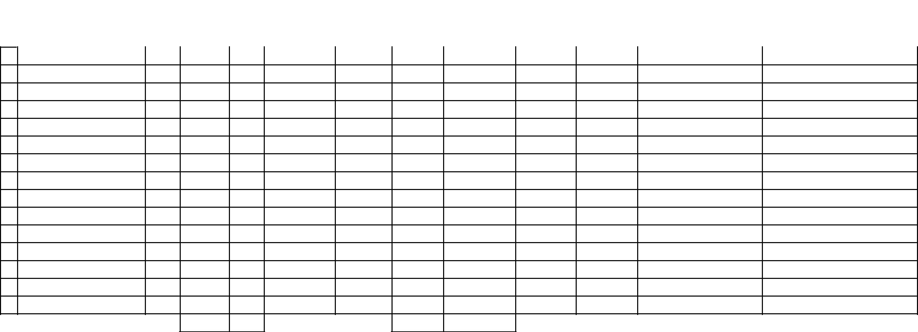
 |  | Square | Square | Lease | Lease | Lease Payment |  | Rent per | CAM Exps | Special Terms and Lease
Tenant | Unit # | Feet | Feet | Commence | Expiration |  |  | Rent per | Paid by | Special Terms and Lease | Type of Business
 |  |  |  |  |  |  |  | Square Foot | Paid by | Options | Type of Business
 |  | Occupied | % | Date | Date | Month | Annual | Square Foot | Tenant | Options

1

2

3

4

5

6

7

8

9

10

11

12

13

14

15

Total

I (we) certify that the above information is true and accurate to the best of my (our) knowledge.

APPLICANT SIGNATURE DATE CO-APPLICANT SIGNATURE DATE

Certified Rent Roll

